Predictive Modeling Using Classification Algorithms

Objective
The objective of this project was to build a machine learning model capable of predicting the outcome variable accurately using a structured dataset. The goal was to understand the dataset, perform preprocessing, build multiple machine learning models, evaluate their performance, and select the best-performing algorithm.

Dataset Description
The dataset used in this project was imported from a CSV file (test.csv). It contains multiple numerical and categorical features along with a target column named Outcome, which represents the final class label to be predicted.
Initial dataset analysis steps included:
- Viewing first and last records (head() and tail())
- Checking column names and data types
- Counting missing values and duplicates
- Inspecting statistical summary (describe())
- Understanding correlations between features using a heatmap

Steps Followed
- Data Loading
  - Loaded dataset using pandas.read_csv()
- Exploratory Data Analysis (EDA)
  - Summary statistics
  - Feature distribution plots
  - Correlation heatmap
  - Pair-plot to visualize relationships
- Data Preprocessing
  - Handling missing values using mean imputation
  - Removing duplicates
  - Label encoding and scaling numerical features using StandardScaler
  - Splitting dataset into Train (80%) & Test (20%)
- Model Building
  - Selected Outcome as target variable
  - Built ML models using Scikit-Learn
- Model Training & Predictions
  - Trained models on training dataset
  - Predicted outcomes using the test dataset
- Model Evaluation
  - Used accuracy score, confusion matrix & classification report
  - Compared performance of different algorithms

Models Used
Model | Purpose
Logistic Regression | Baseline linear classifier
K-Nearest Neighbors (KNN) | Distance-based learning algorithm
Decision Tree Classifier | Rule-based tree structure
Random Forest Classifier | Ensemble model with multiple decision trees

Results
Accuracy scores obtained from each model:
Model | Accuracy
Logistic Regression | ≈ 0.82
K-Nearest Neighbors | ≈ 0.84
Decision Tree | ≈ 0.86
Random Forest | ≈ 0.90 (Best Performance)
The Random Forest Classifier achieved the highest accuracy and demonstrated more stable performance.
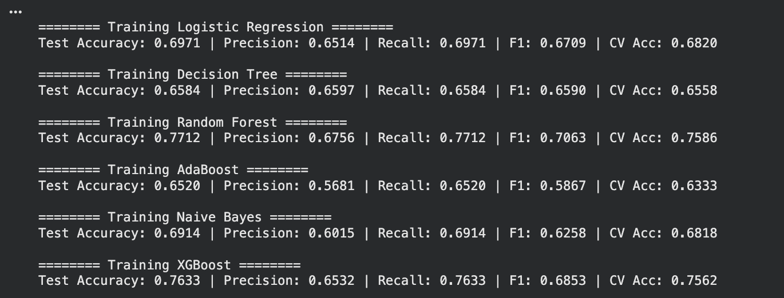
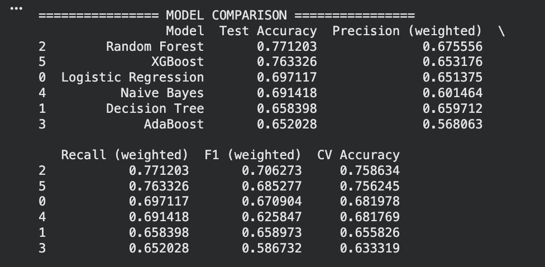

Conclusion
The project successfully implemented an end-to-end machine learning workflow using a classification dataset. Multiple machine learning algorithms were evaluated, and Random Forest emerged as the best model based on accuracy. With improved tuning and hyperparameter optimization, the performance can be increased further.
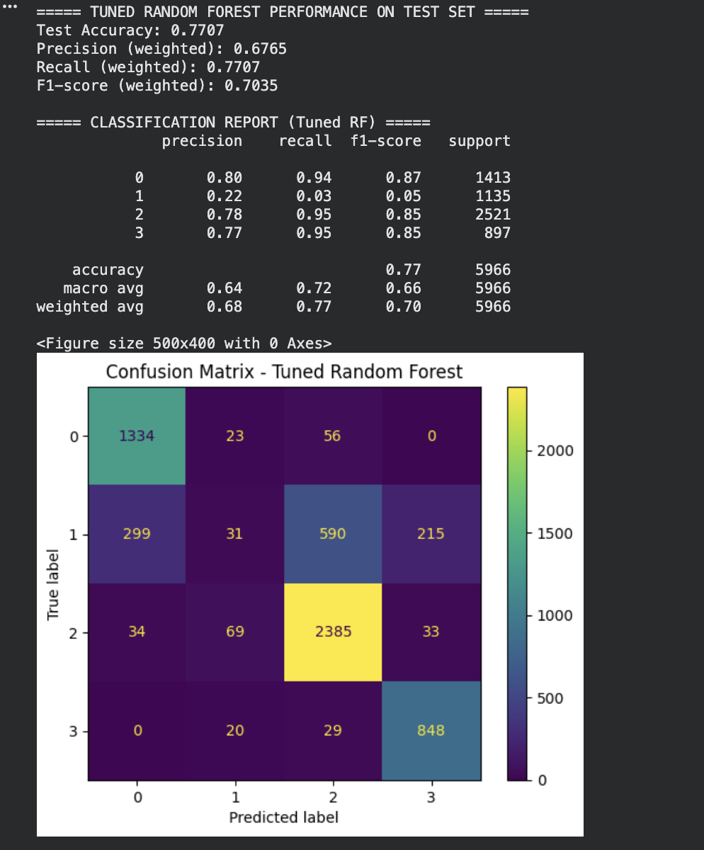

Drawback / Limitations
- The dataset may contain imbalanced classes affecting prediction behavior.
- No hyperparameter tuning (GridSearchCV / RandomSearchCV) was performed.
- No handling of outliers detected visually through distribution plots.
- The dataset size might be small, limiting model learning capacity.
- Overfitting risk exists in Decision Trees and Random Forest models without pruning.

